**Data Structures and Algorithms**

**Topics:**

1. Singly Linked List
2. Doubly Linked list
3. Singly Circular Linked list
4. Arrays
5. Stacks
6. Queues
7. Binary Tree
8. Binary Heaps
9. Graphs
10. Matrix
11. Tries

**What is Data Structures?**

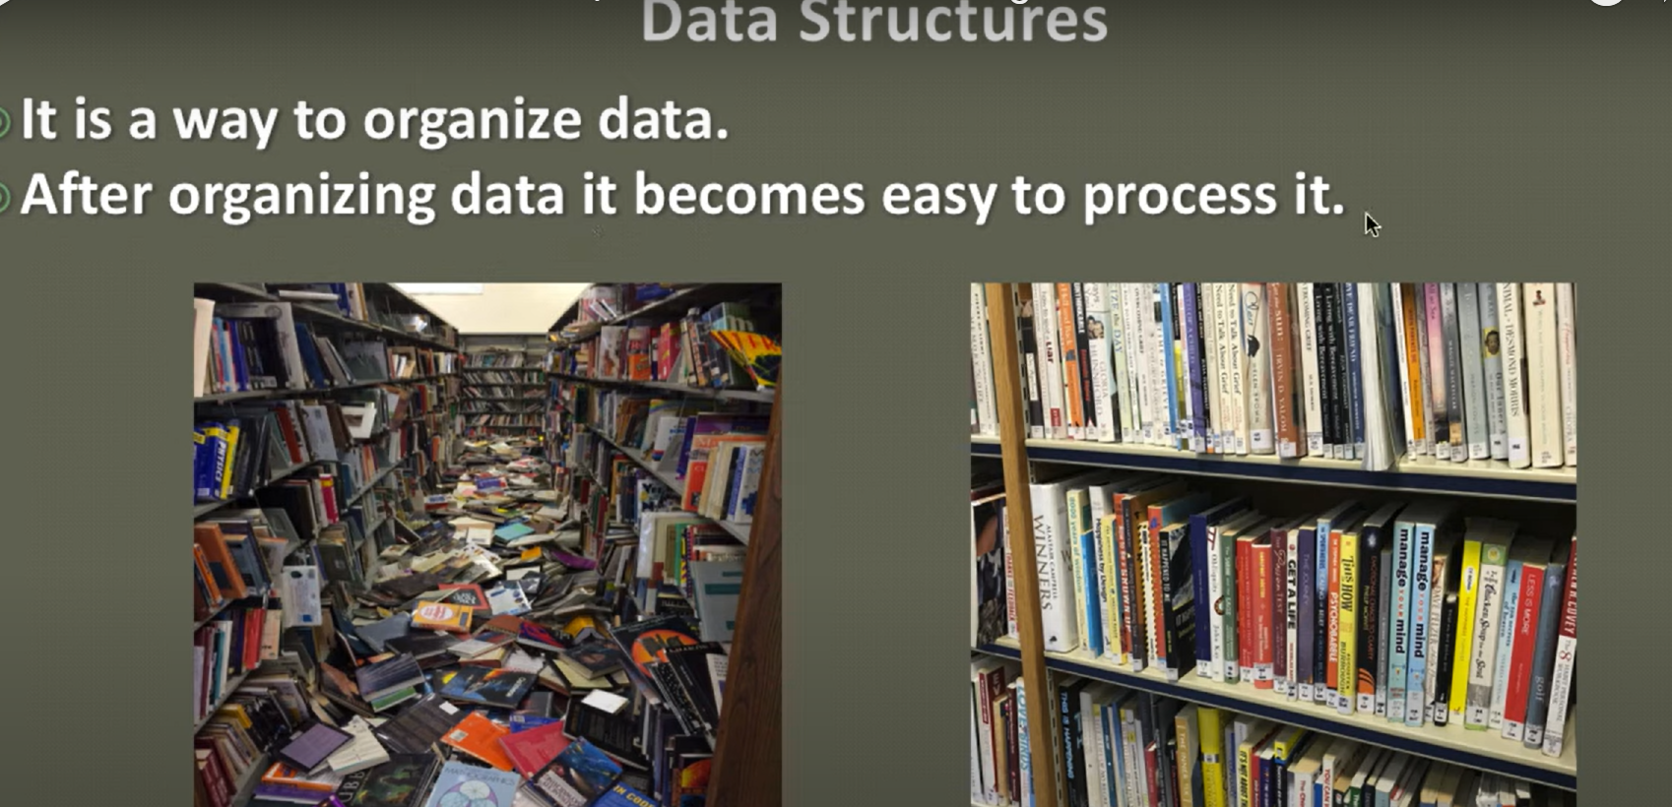

**Types of Data Structures:**

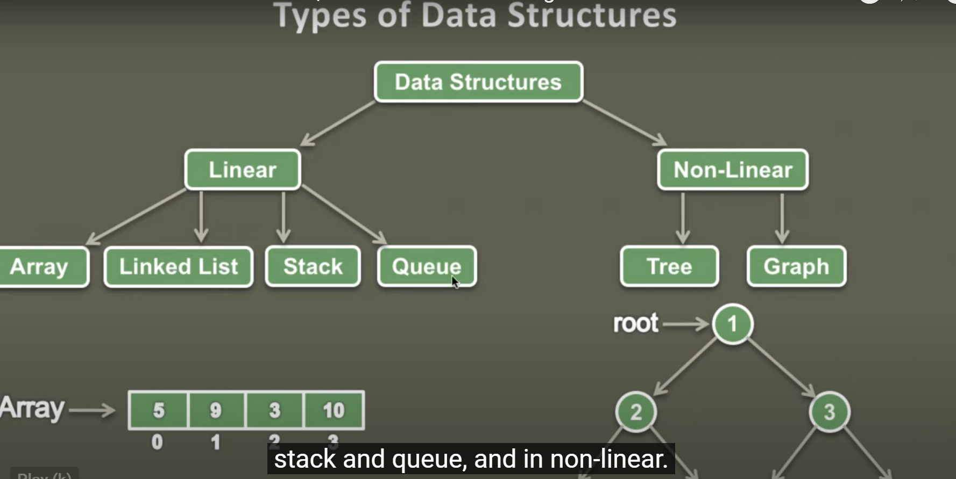

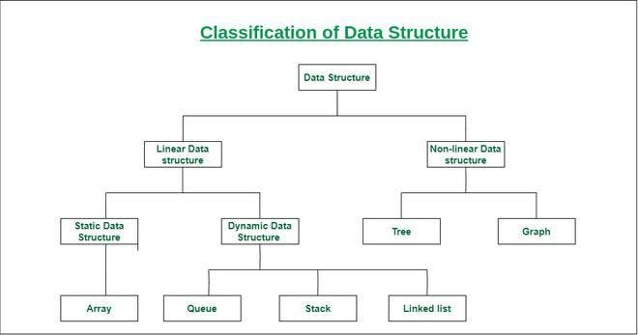

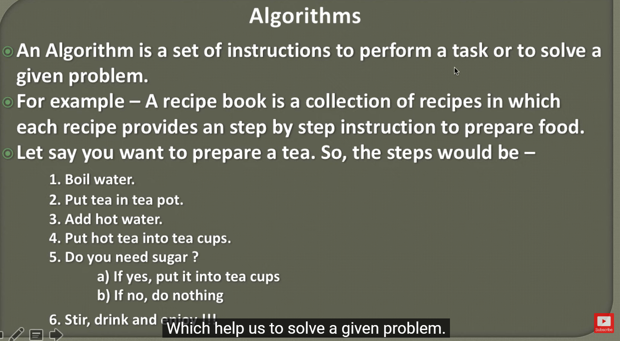

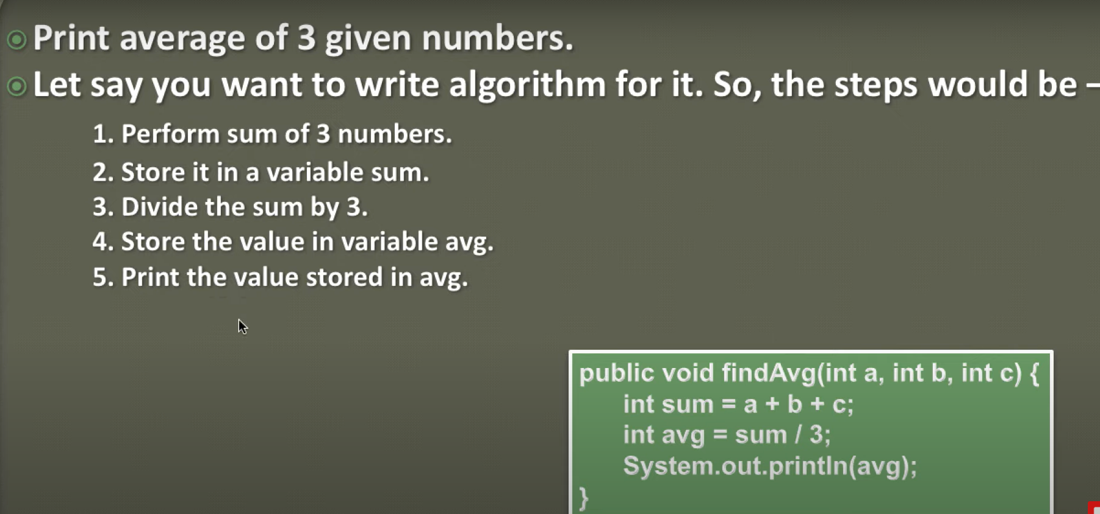

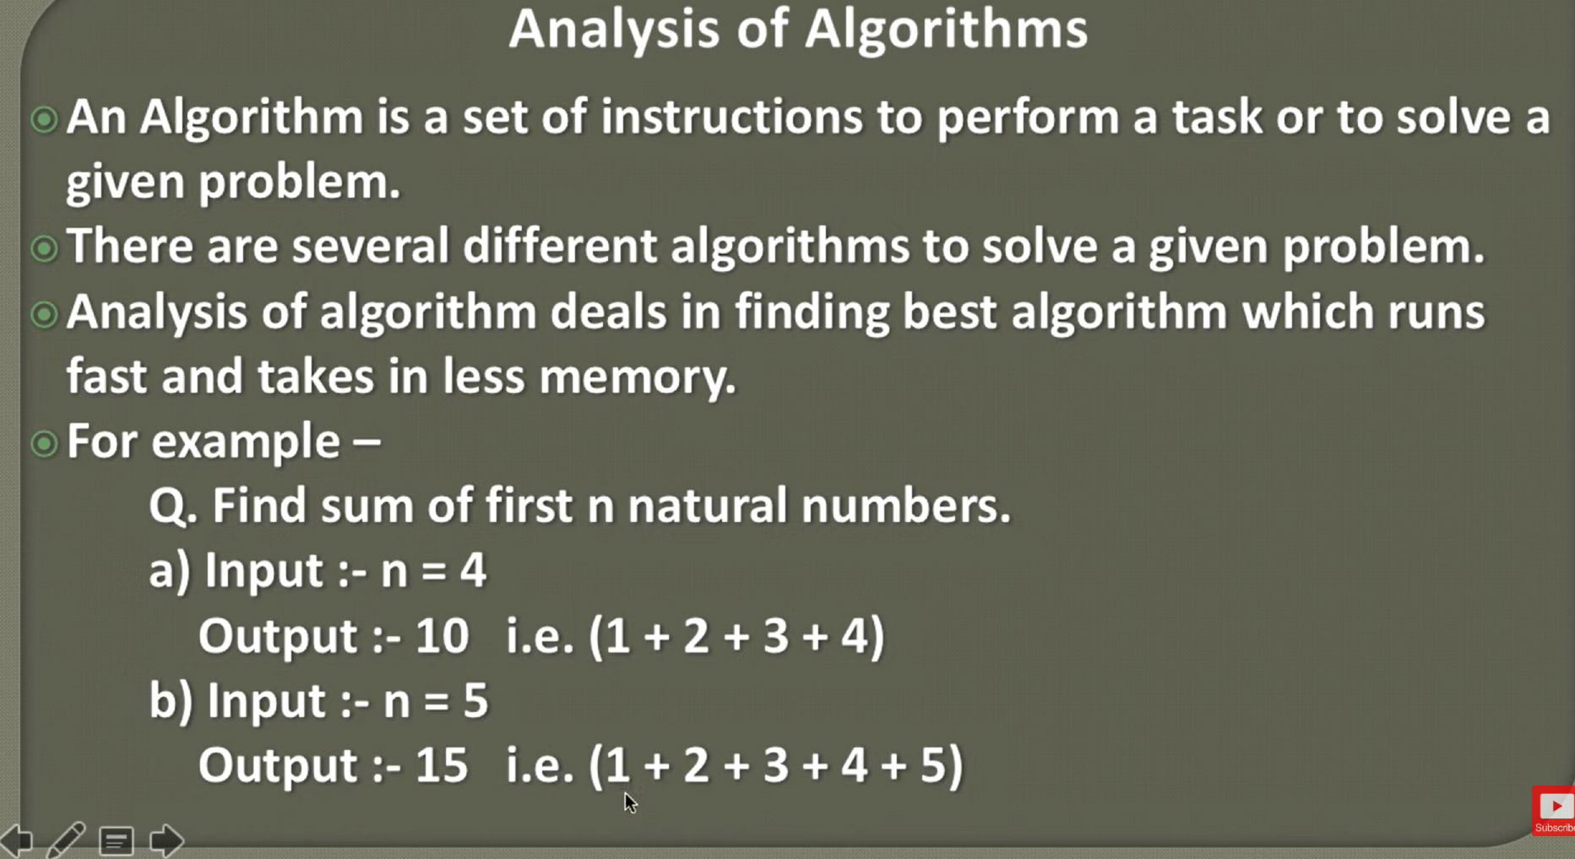

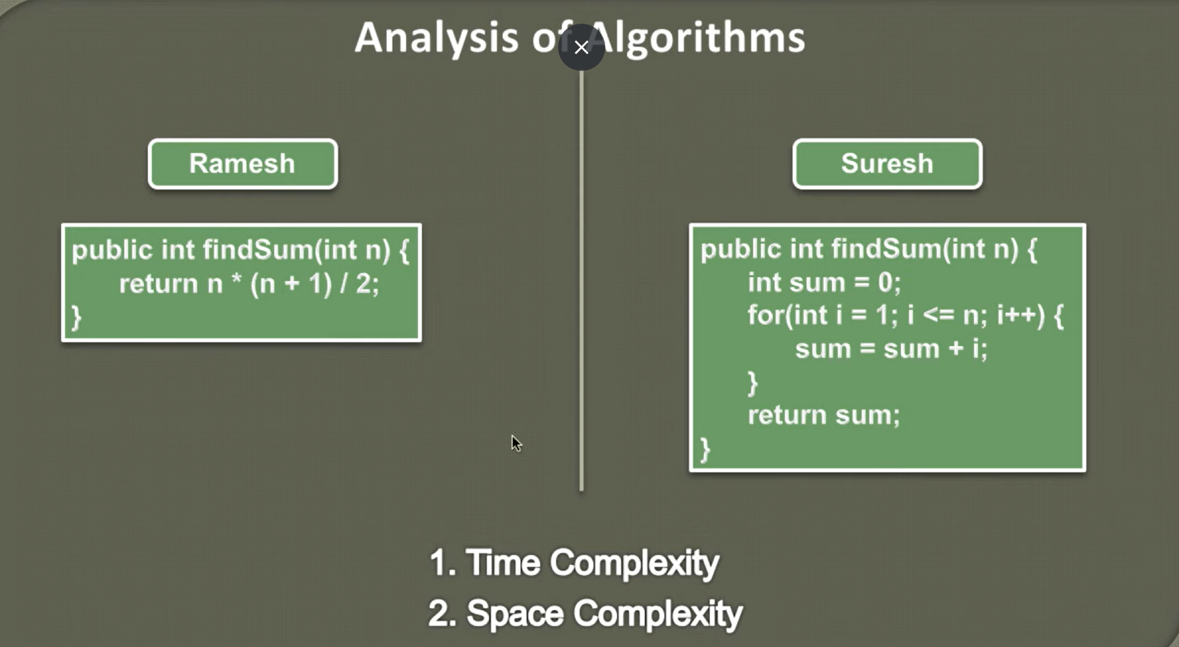

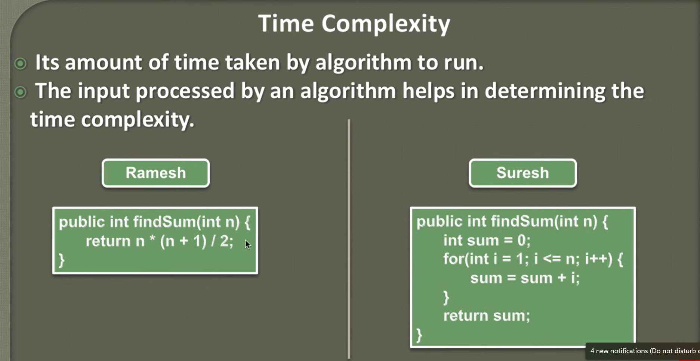

Example in IDE:

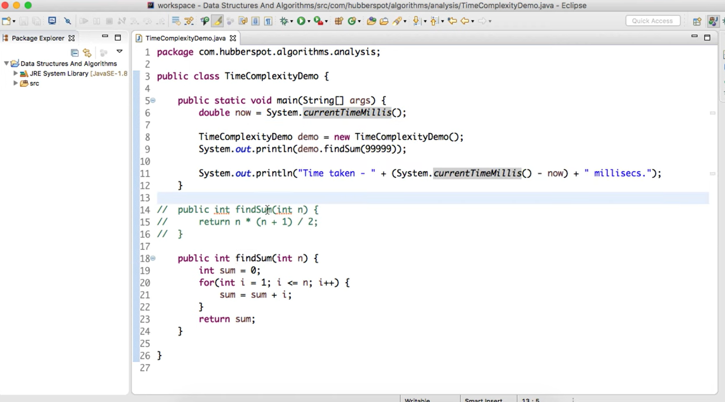

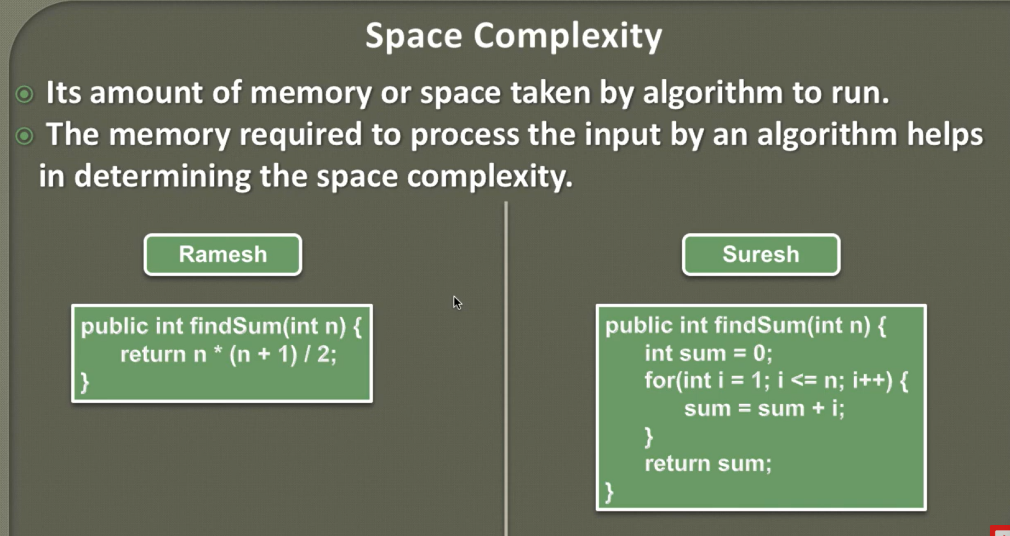

There are some mathematical models which determines time and space complexity of and Algorithm:

**Asymptotic Analysis of an Algorithm**

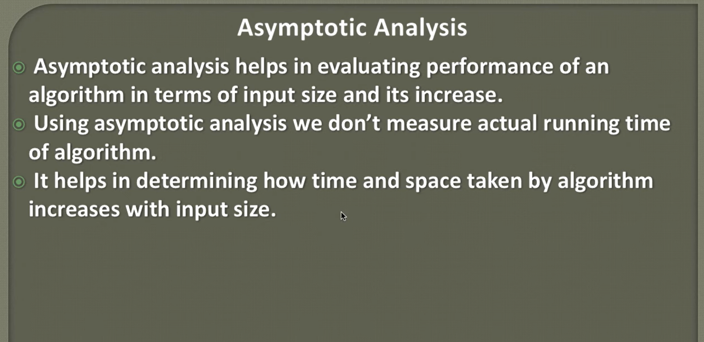

**Asymptotic Notations:**

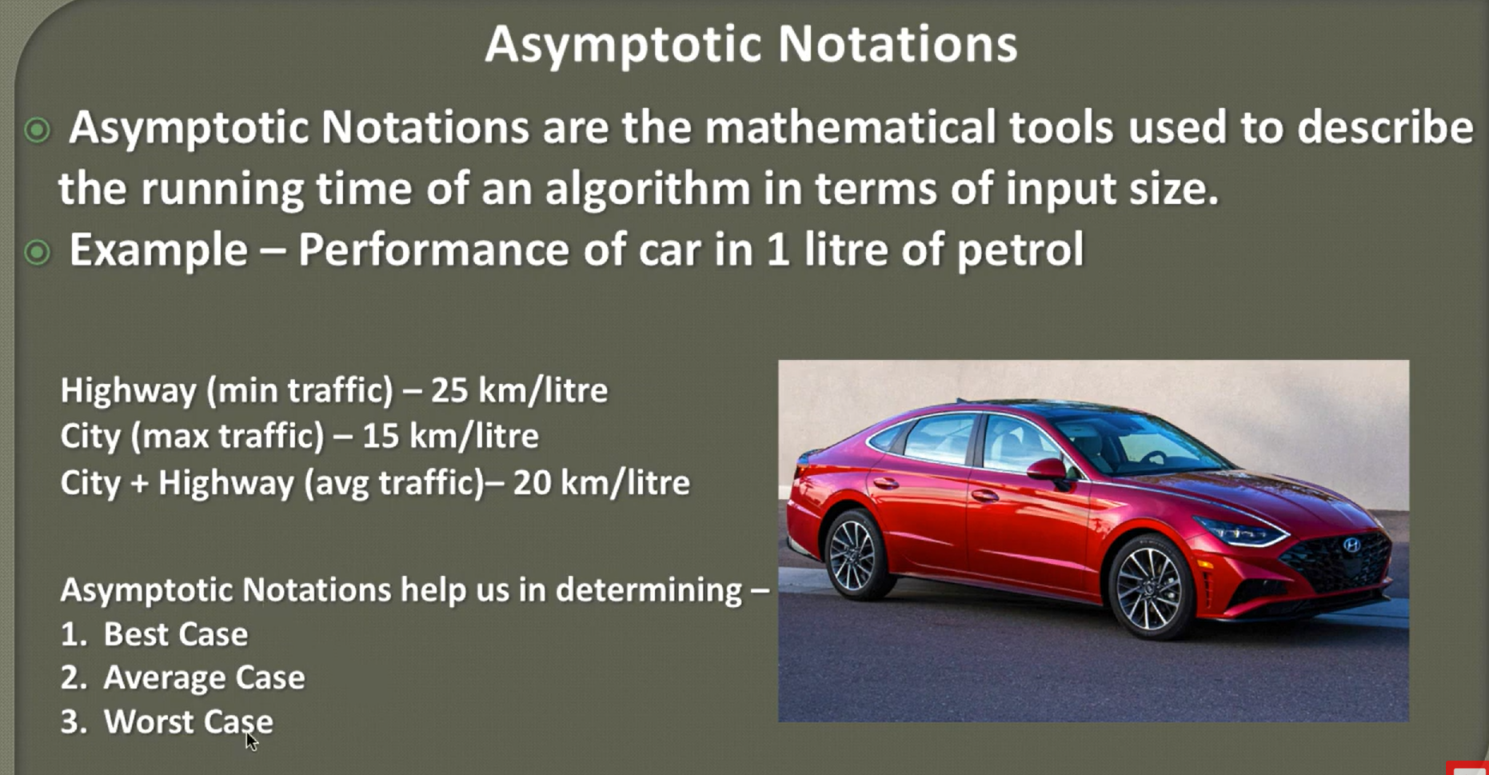

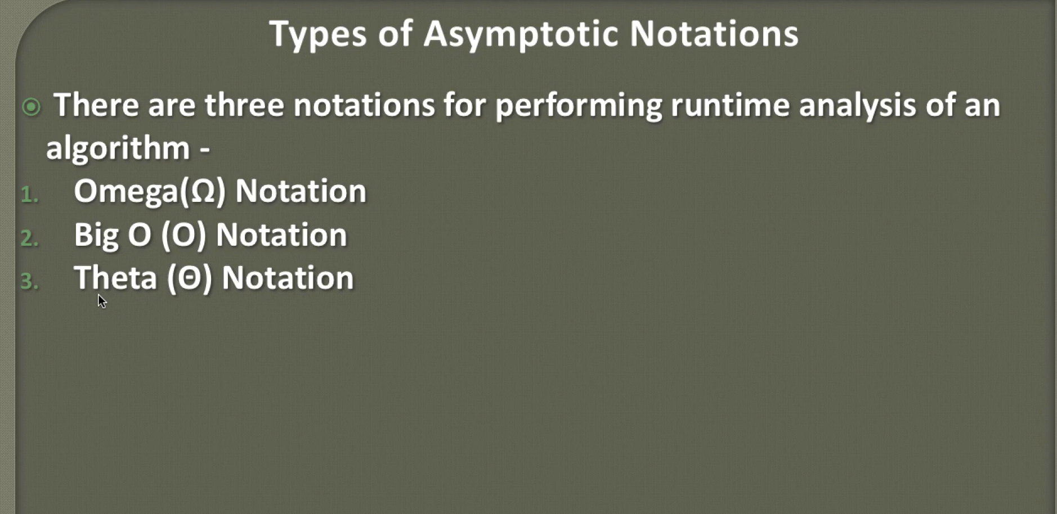

**1 Omega Notation: (Minium time /lower bound) – Best Case**

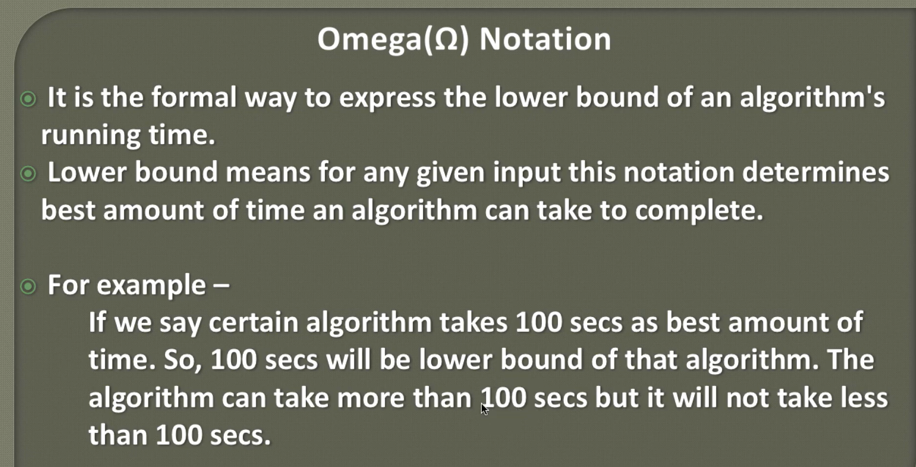

**2. Biig O notation: (Worst case) Maximum time**

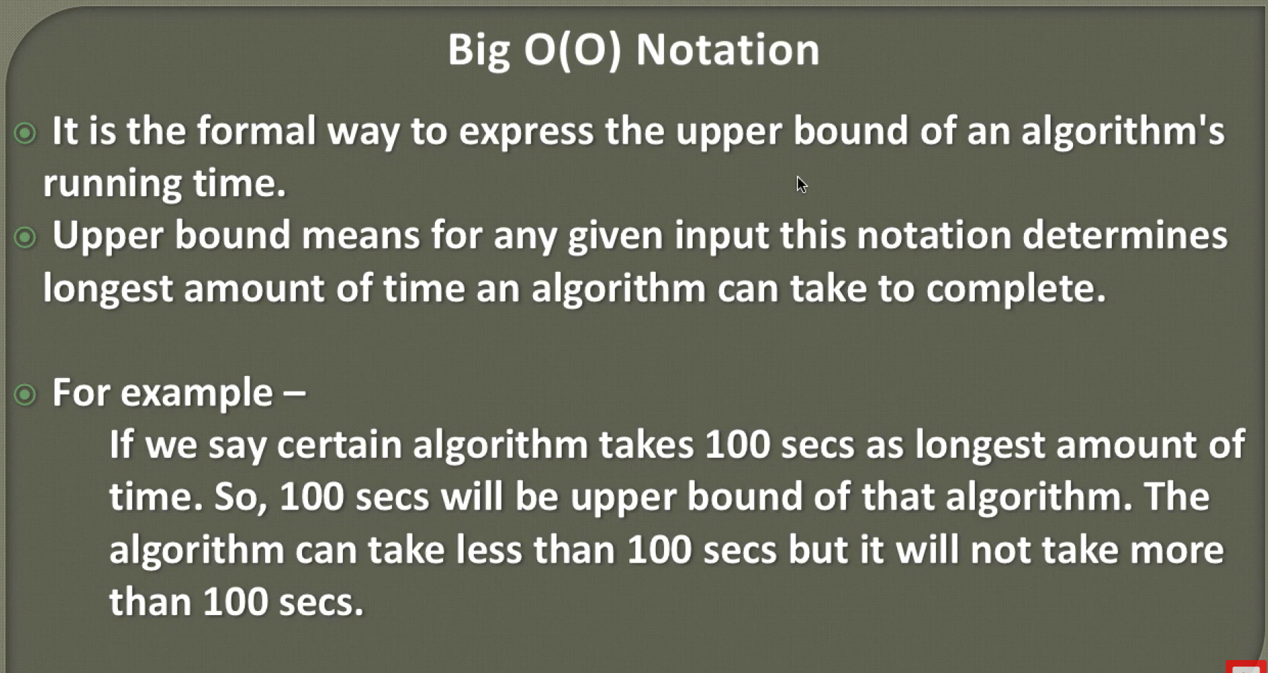

**3. Theta Notation: (Average Case)**

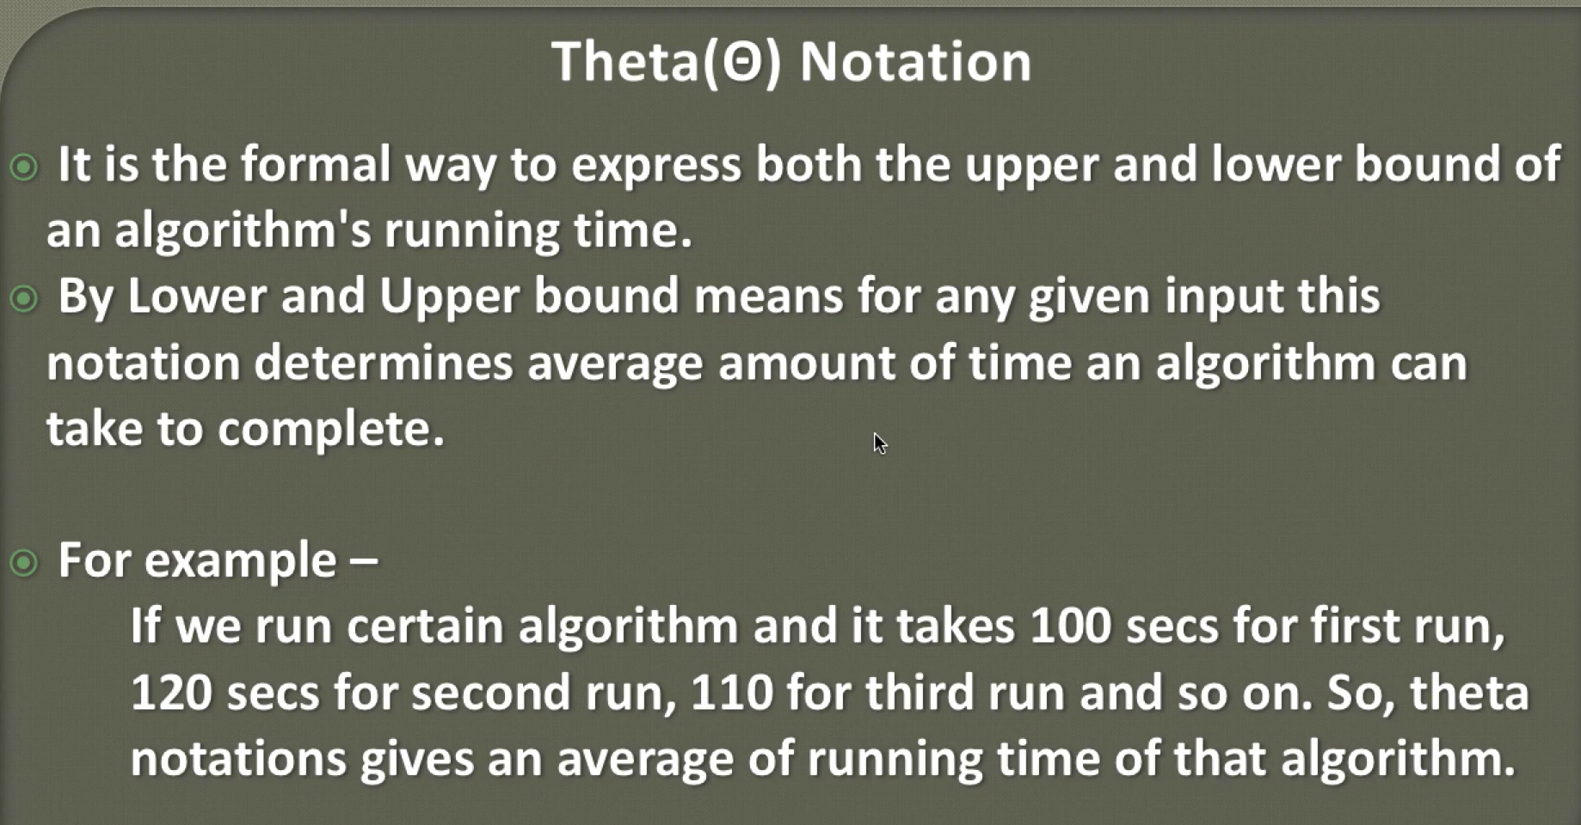

**Analysis of Time Complexity (Big O Notation):**

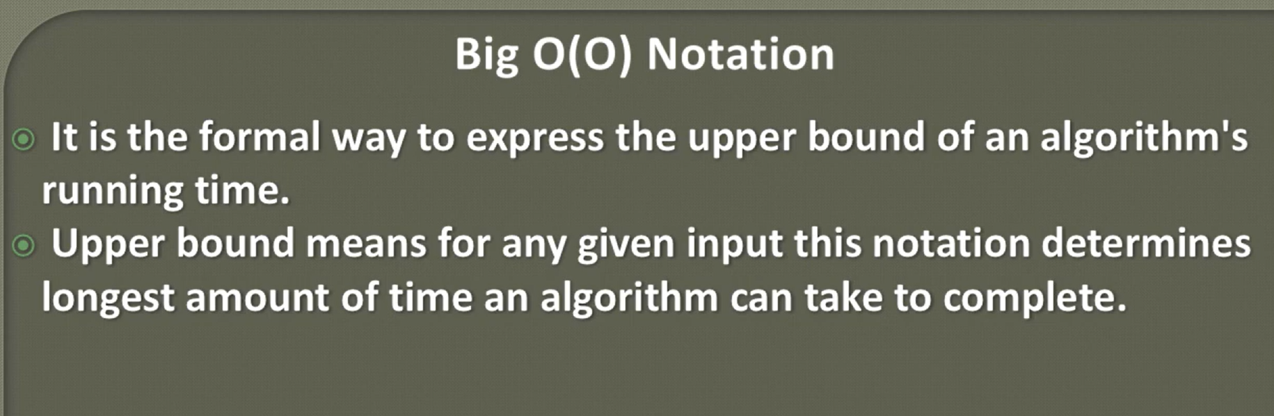

**Rules of Big O Notation:**

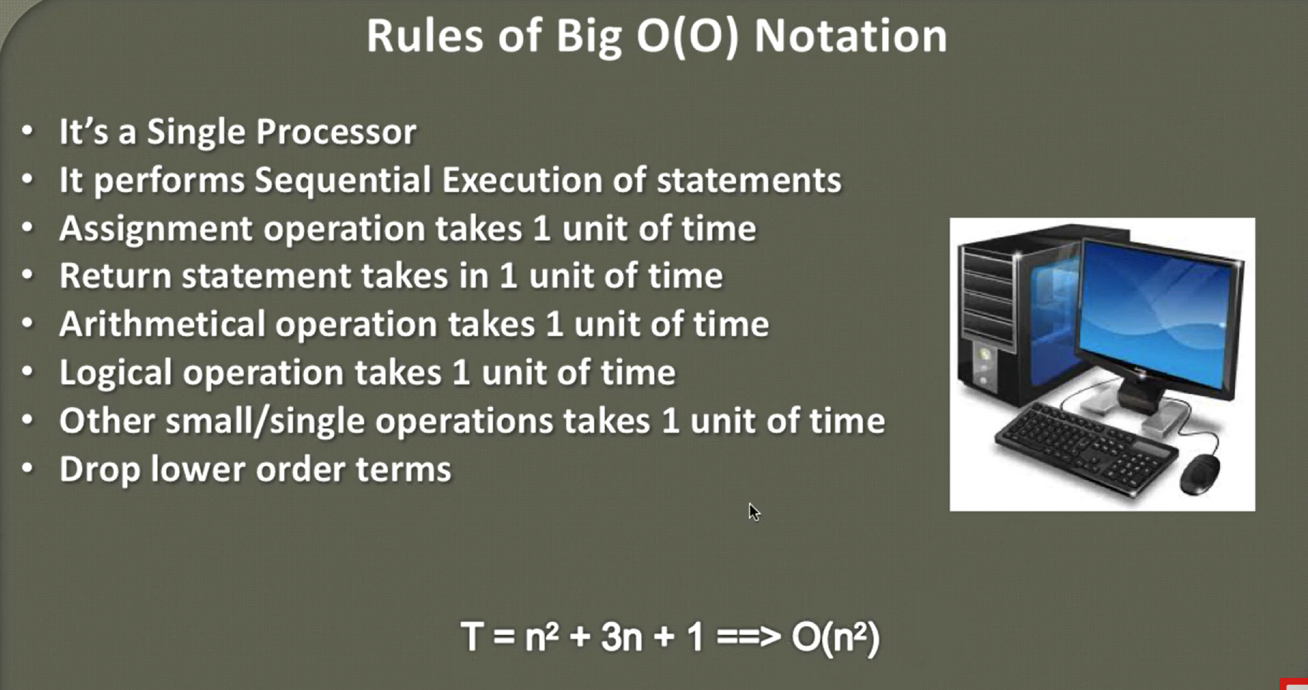

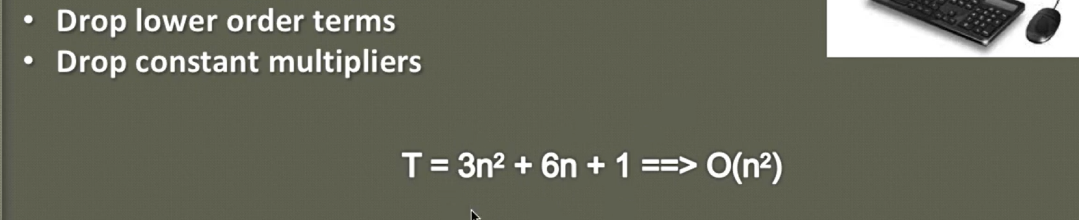

**Calculating Time Complexity of Constant Algorithm:**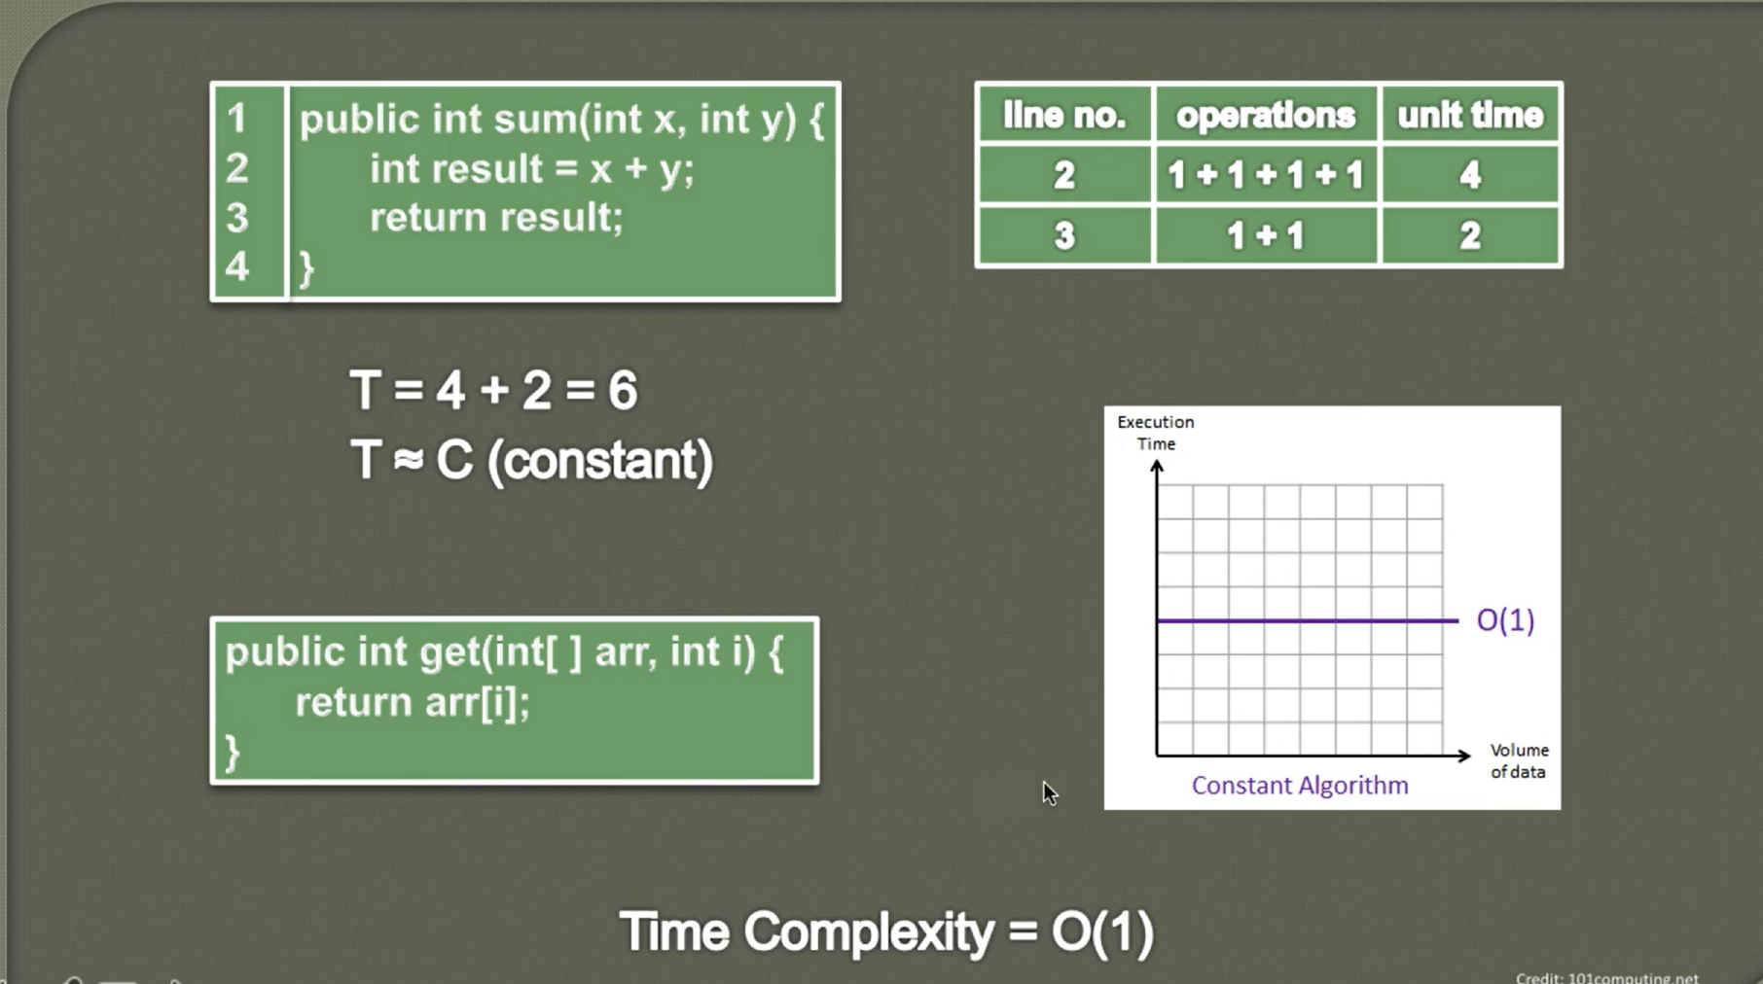

**Lin**

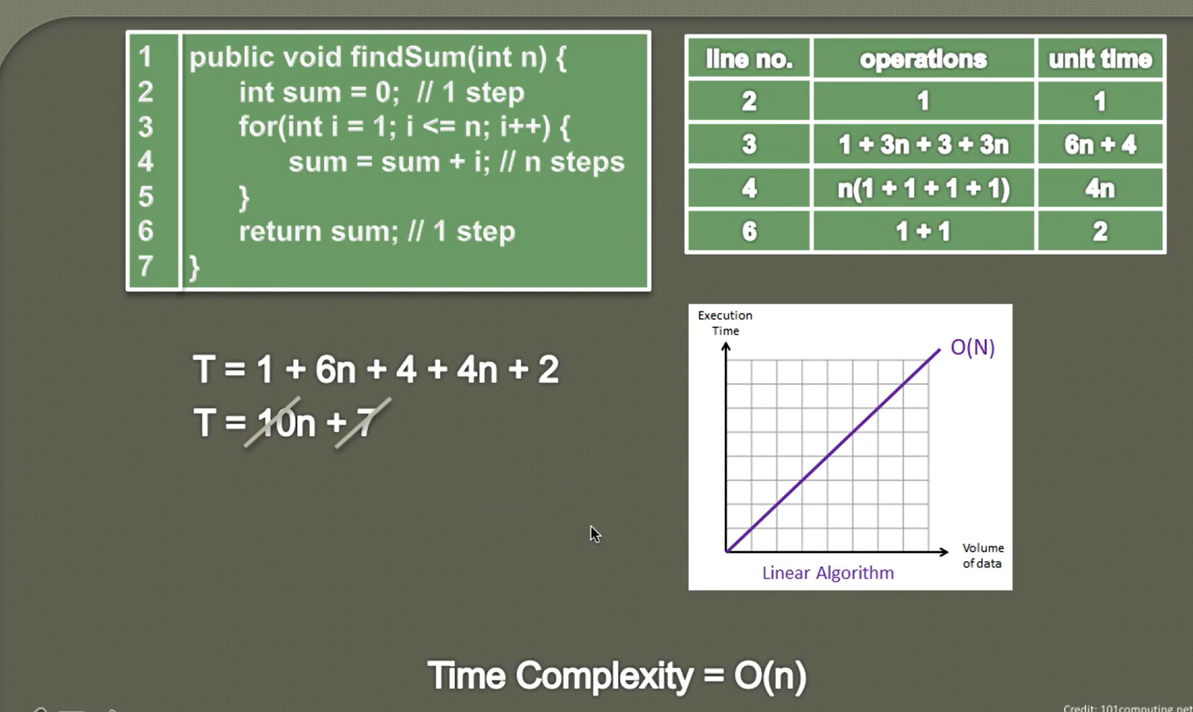

**Polynominal Algoritham(Big O):**

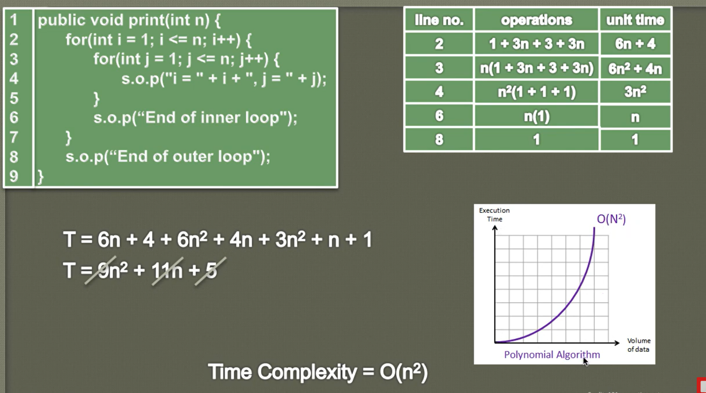

**Array Data Structure:**

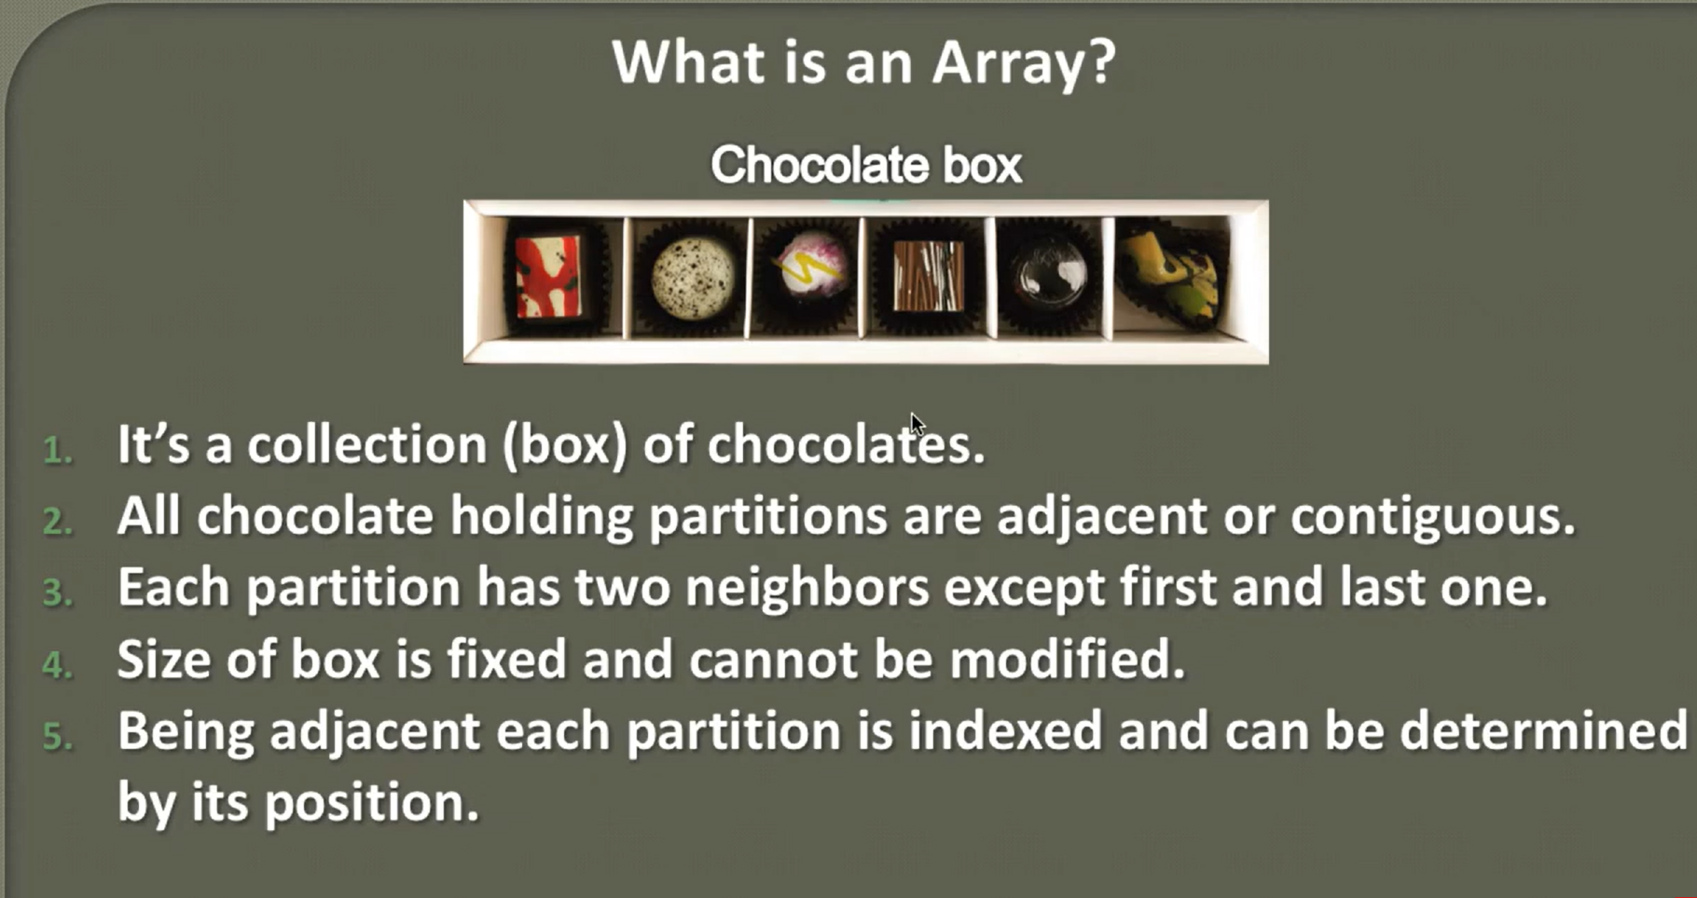

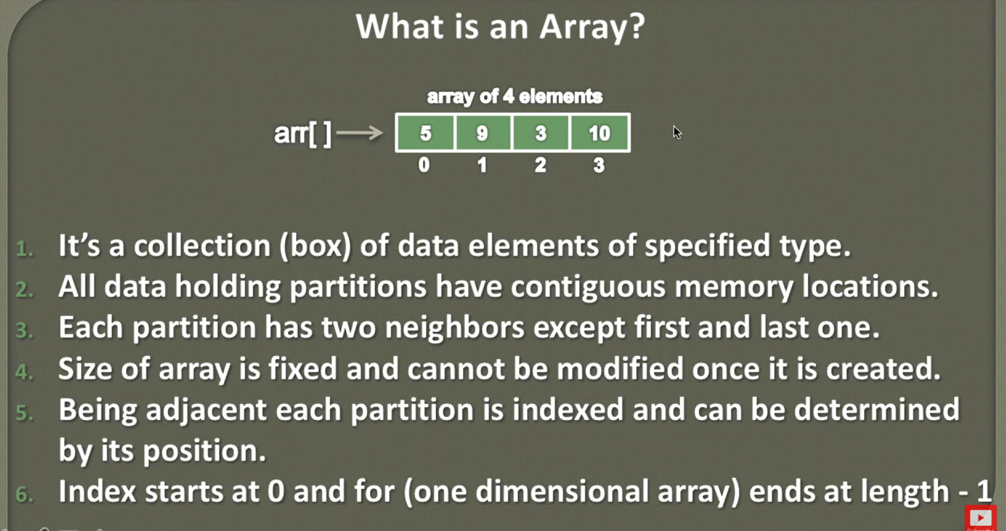

**Why array index starts from 0 in java?**

Reference Links:

<https://medium.com/@varshilshah.in/why-array-indexing-starts-from-zero-11572281920>

<https://medium.com/@piyush.kochhar1/why-array-index-begins-with-0-9adfef92223a>

**Array indices in Java (and many other programming languages) start from 0 due to historical and practical reasons rooted in computer science. Here are the main reasons:**

1. **Historical Context**:

    - The tradition of zero-based indexing comes from early programming languages like C. C's array indexing directly corresponds to memory addresses, where the index serves as an offset from the starting memory address. The first element is at the starting address plus zero, hence index 0.

2. **Pointer Arithmetic**:

    - In languages like C and C++, arrays are closely tied to pointer arithmetic. For example, if an array starts at memory address `p`, the element at index `i` is located at `p + i * sizeof(element)`. Starting the index at 0 means the first element is exactly at the address `p`, simplifying this calculation.

3. **Simplicity and Efficiency**:

    - Zero-based indexing can simplify the implementation of arrays and reduce the chance of off-by-one errors in calculations. It aligns with the way memory addressing works, thus allowing more straightforward and efficient computation.

4. **Consistency Across Languages**:

    - Many modern programming languages (such as Java, Python, and JavaScript) have adopted zero-based indexing for consistency with C and other early languages. This makes it easier for developers to switch between languages without having to adjust to different indexing conventions.

5. **Mathematical Convenience**:

    - In many mathematical contexts, zero-based indexing can be more convenient. For instance, in modulo arithmetic and many algorithms, starting from 0 can simplify calculations and loop conditions.

These reasons combine to make zero-based indexing a standard choice for arrays in Java and many other programming languages.

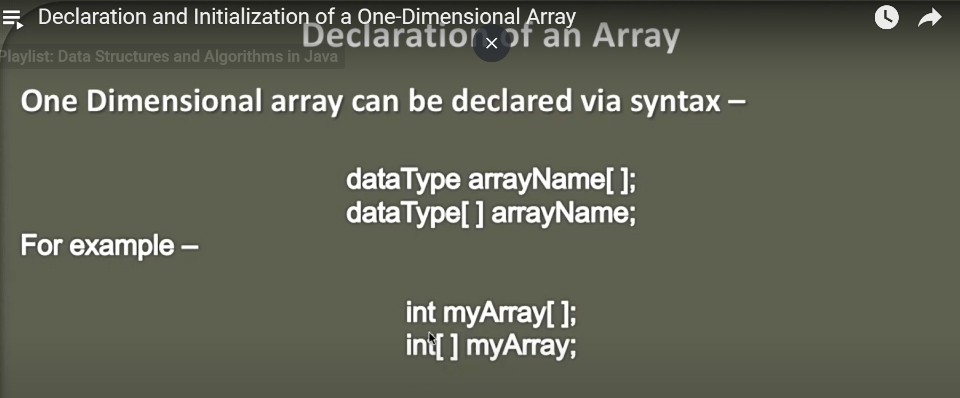

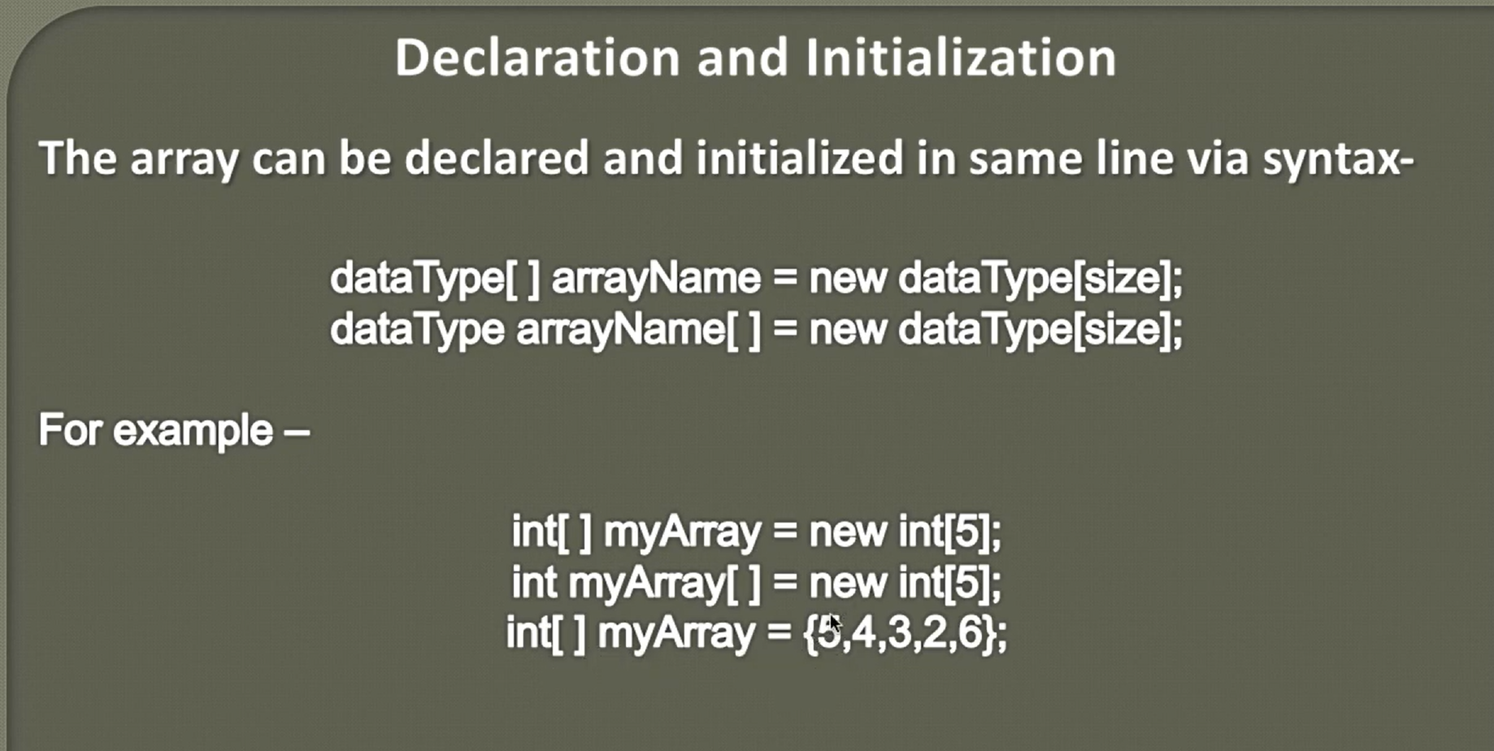

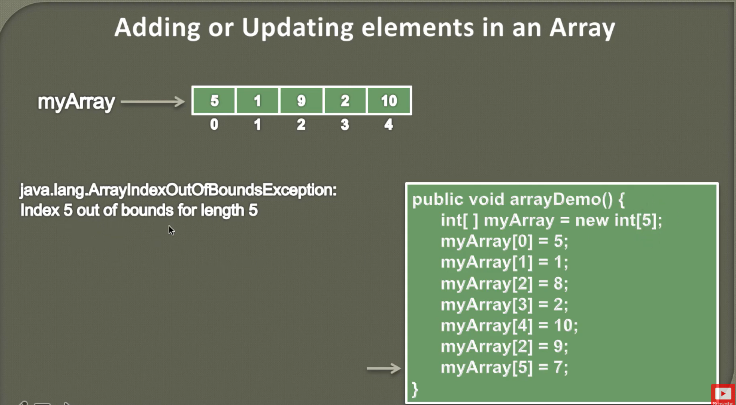

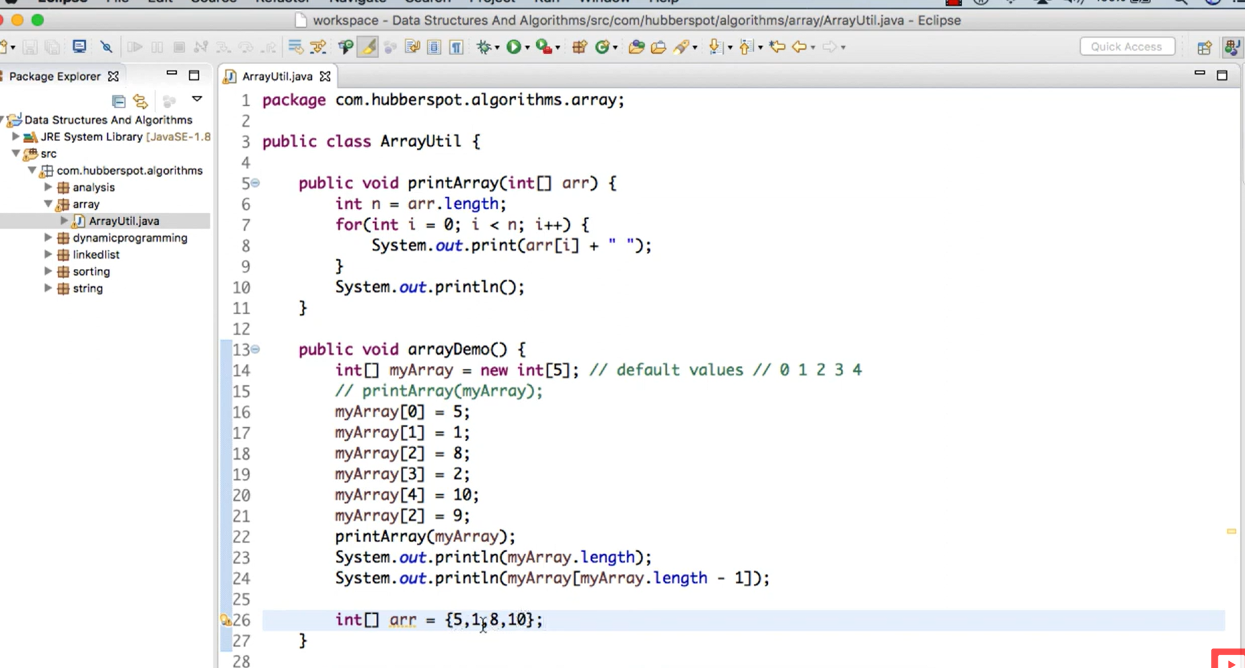

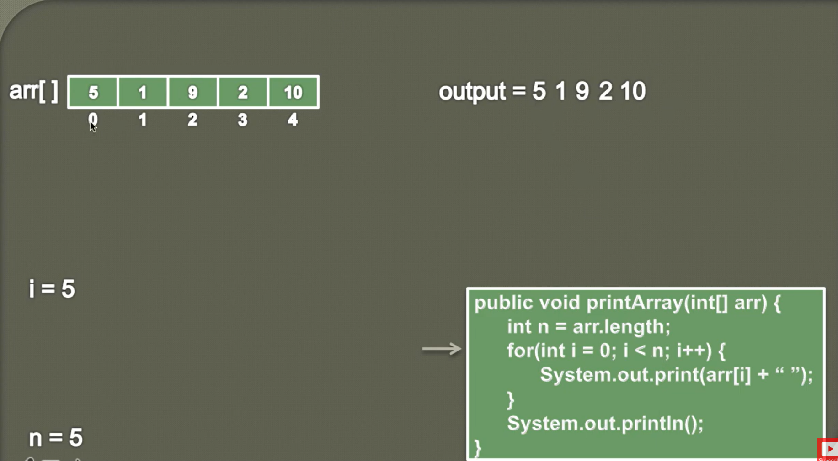

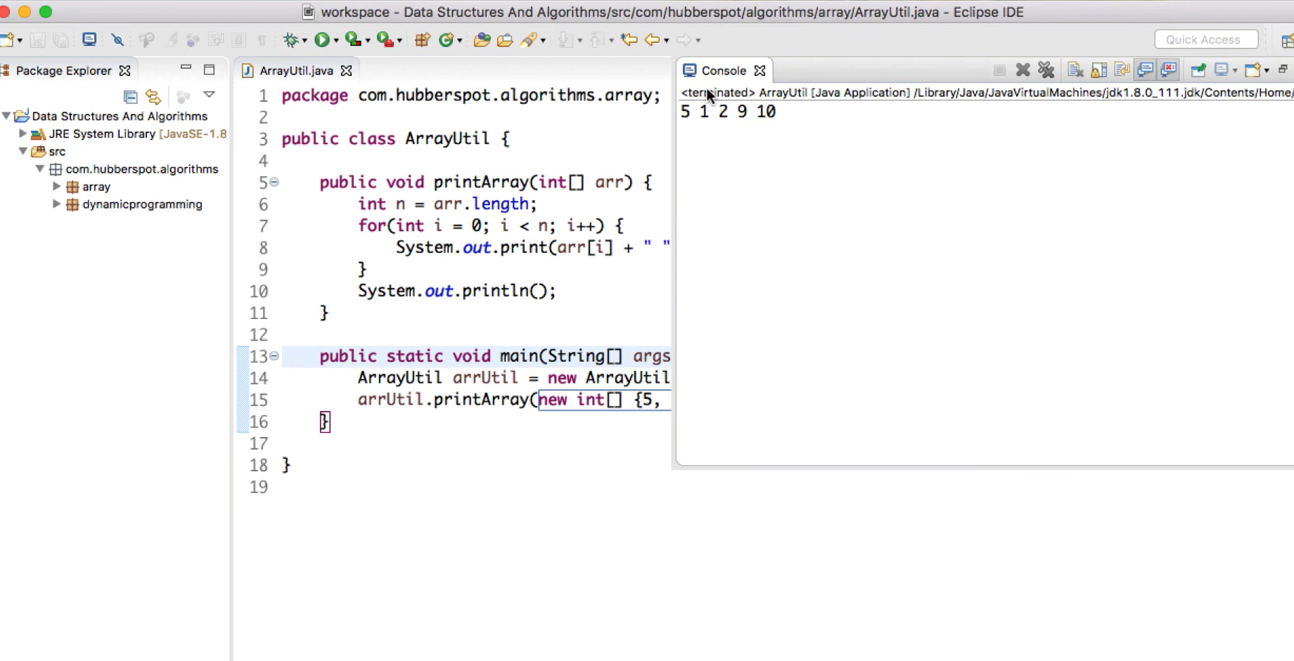

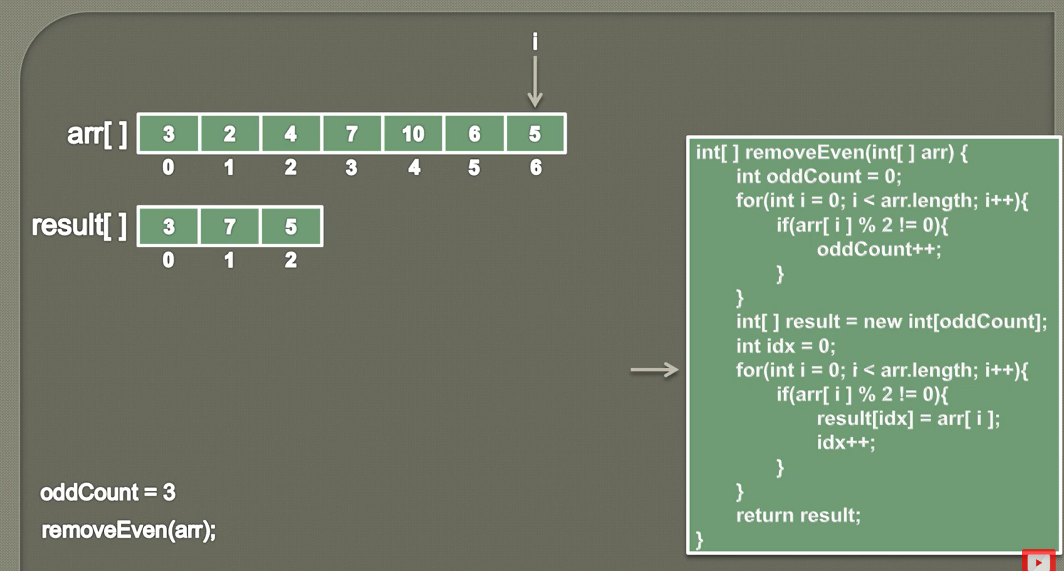

1. **How to find second mx and second min value from given array?**
2. **How to move all zeros to the end of array? By maintaining relative order of non-zero values?**

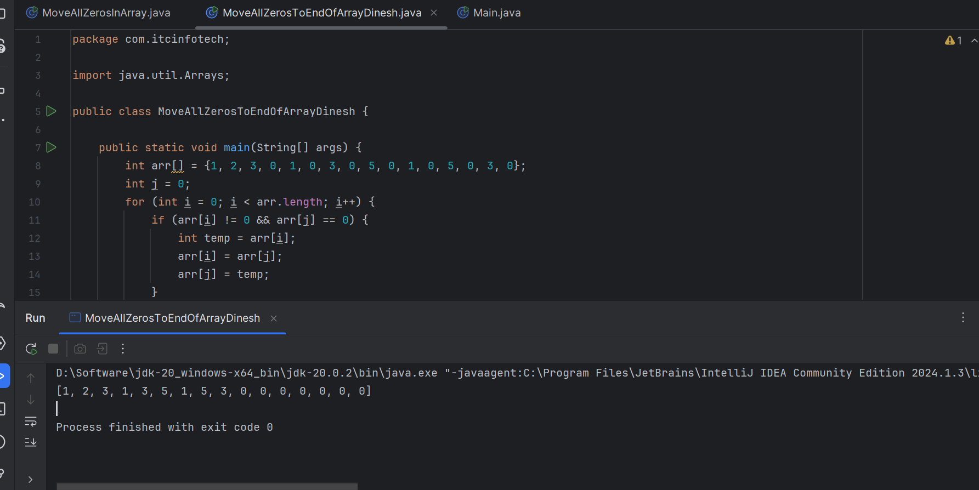

Videos number – 31

Q) How to re-size of array ?

**Important Notes:**

1. When you try to change the reference of parameter/another method stack variable in another method stack area with another local variable which is created inside the called method area, it will not impact the parameterized variable reference. After method execution completes, all the method local variable sand assignments will not not have considered and it will be eligible for garbage collector.
2. What we should understand like, one method stack areas references will not impact another method stack created reference variables. For below examples – **arr** and **temp** array variables.
3. Here **line number 25**, we assigned **arr = temp**, still we are not seeing those changes in main method place as resize() method will not impact the the other method stack area variables.

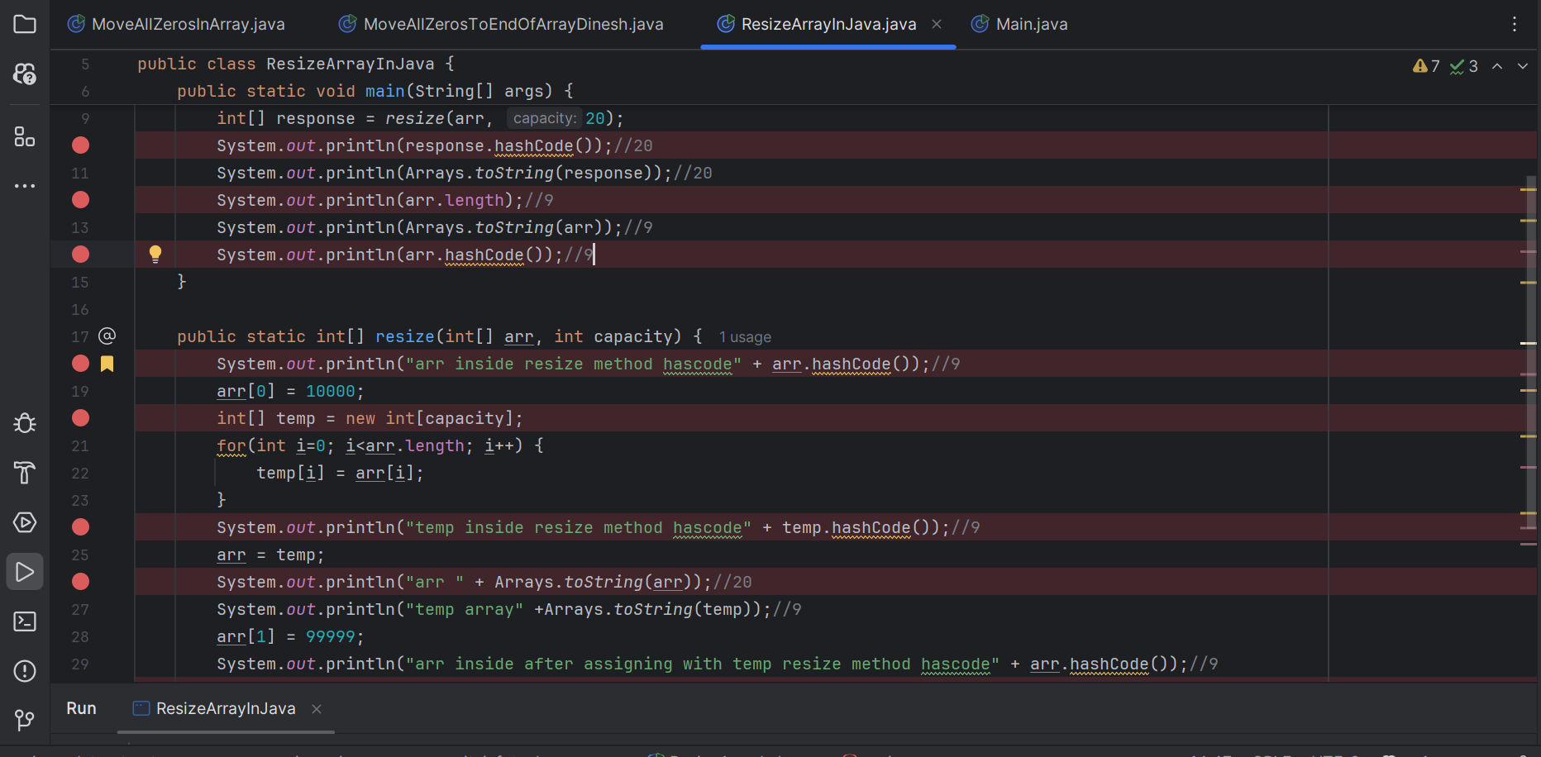

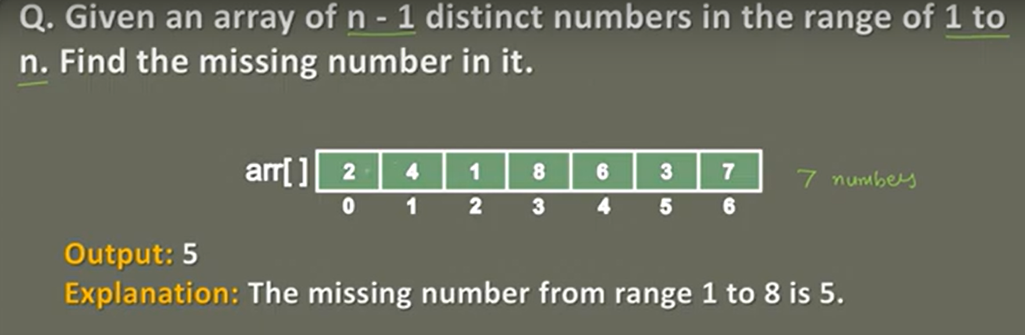

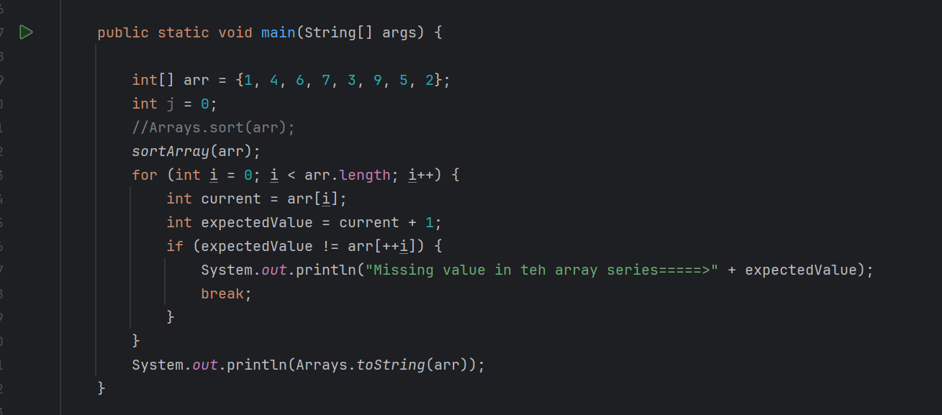

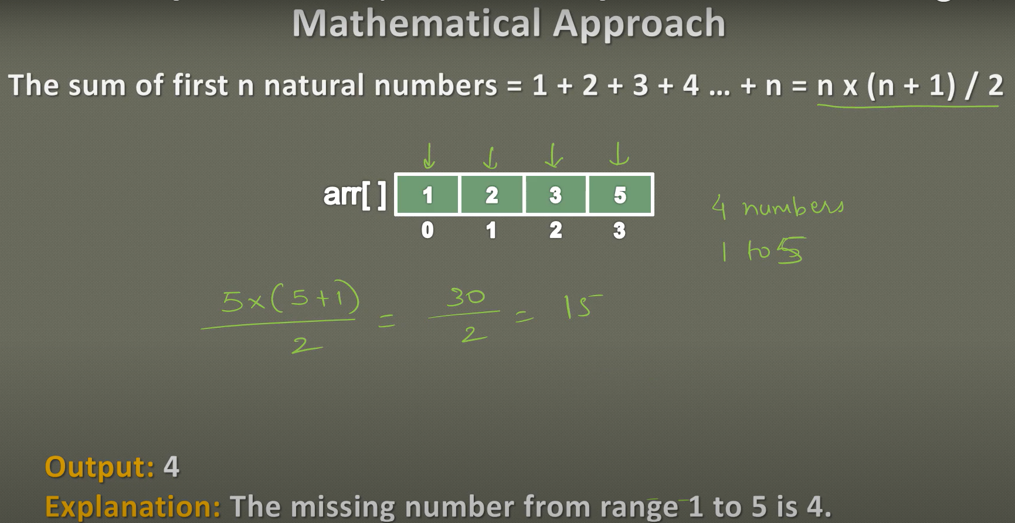

25th june 2024- starting video 34- <https://www.youtube.com/watch?v=Q485CWk_QWk&list=PL6Zs6LgrJj3tDXv8a_elC6eT_4R5gfX4d&index=34>

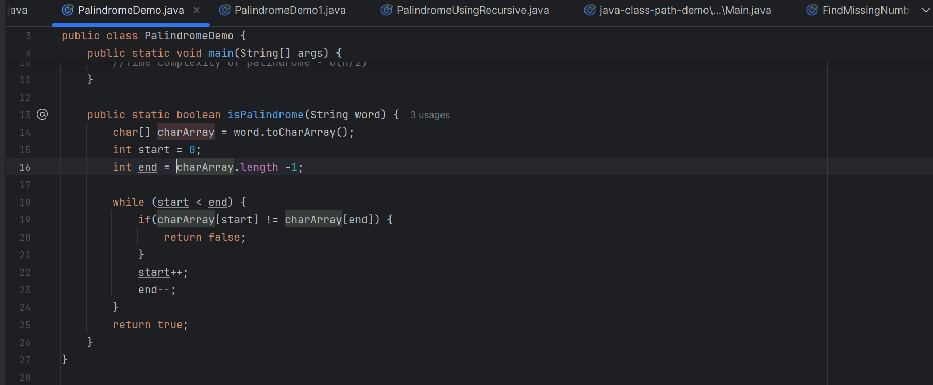

26th June 2024:

**Represent Singly Linked List in Java:**

**What is Node?**: Node is a network component or a device that is part of a larger network. It can be a computer, a printer, a router, or any other electronic device that is connected to a network. The term "node" stands for "Network Open Distributed Environment" and it represents a specific location in a network.

NODE - "Network Open Distributed Environment"

<https://www.linkedin.com/pulse/node-full-form-justacademy-pune-hlmrc/>

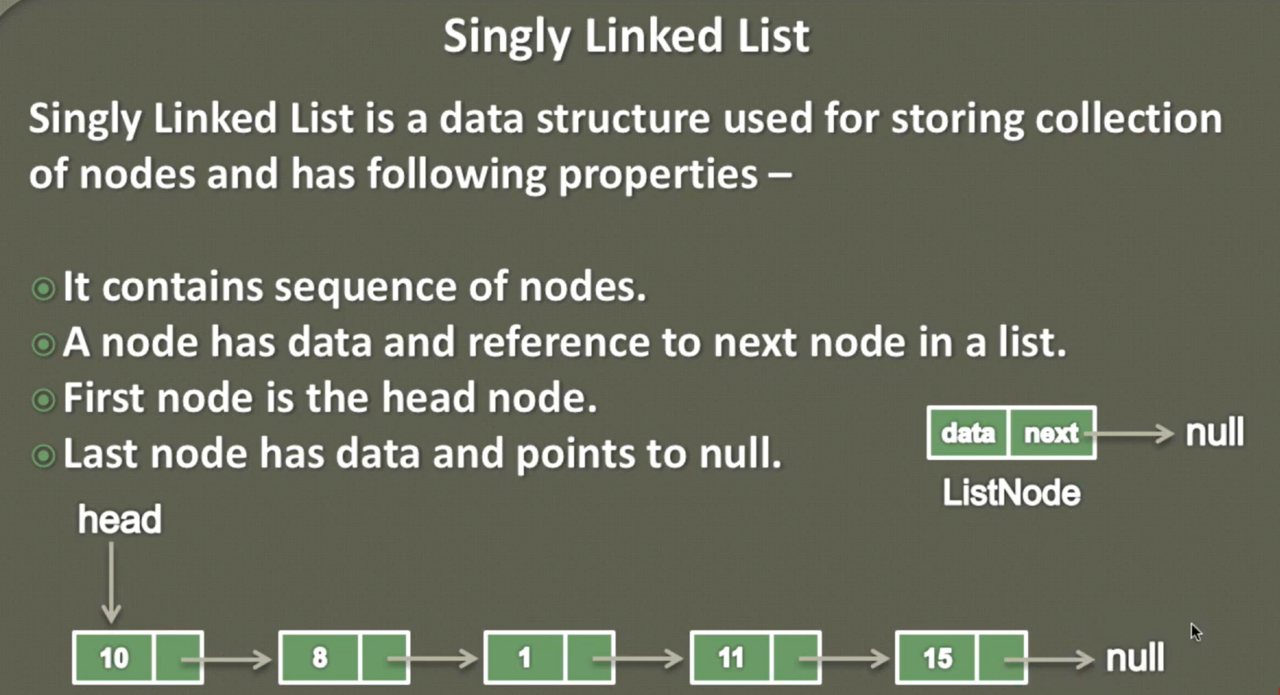

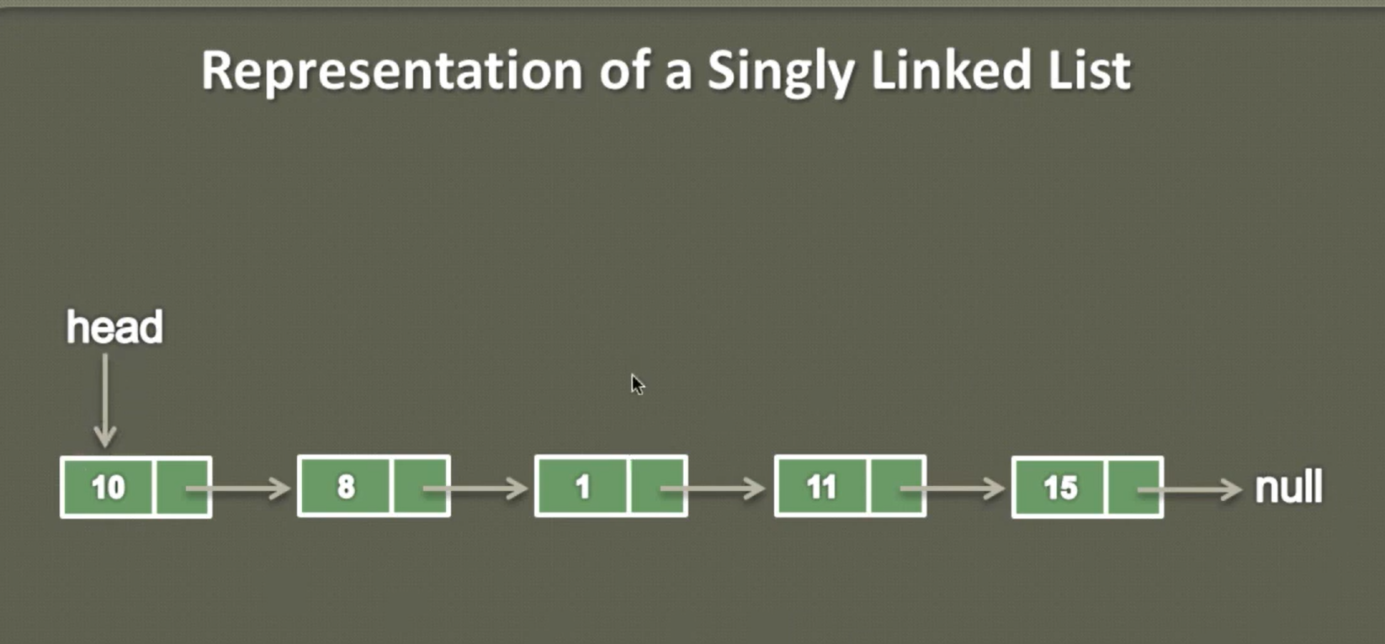

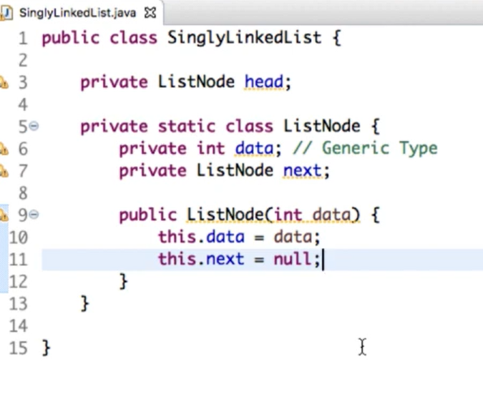

**Videos – 38 - How to create single linked list in java:**

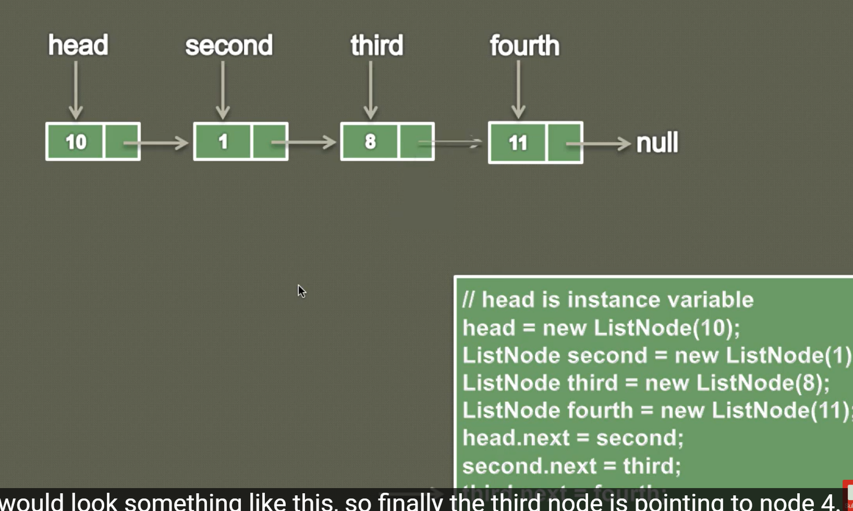

**Pass by value vs Pass by refrence:**

**Pass by value in Java:** Java is a pass-by-value language in both cases — primitive data types as well as objects. When passing objects to methods, it’s important to remember that their reference values (memory addresses) are being passed by value

Example 1: Primitive Data Types

|  |
| --- |
| public class PassByValueDemo {  public static void main(String[] args) {  int number = 10;  System.out.println("Before: " + number); // Output: Before: 10  modifyNumber(number);  System.out.println("After: " + number); // Output: After: 10  }  public static void modifyNumber(int value) {  value = value * 2;  System.out.println("Modified: " + value); // Output: Modified: 20  }  } |

**Example 2: Objects**

|  |
| --- |
| public class PassByValueDemo {  public static void main(String[] args) {  Point point = new Point(2, 3);  System.out.println("Before: " + point); // Output: Before: (2, 3)  modifyPoint(point);  System.out.println("After: " + point); // Output: After: (20, 30)  }  public static void modifyPoint(Point point) {  point.setX(point.getX() * 10);  point.setY(point.getY() * 10);  System.out.println("Modified: " + point); // Output: Modified: (20, 30)  }  }  class Point {  private int x;  private int y;  public Point(int x, int y) {  this.x = x;  this.y = y;  }  public int getX() {  return x;  }  public void setX(int x) {  this.x = x;  }  public int getY() {  return y;  }  public void setY(int y) {  this.y = y;  }  @Override  public String toString() {  return "(" + x + ", " + y + ")";  }  } |

**Reference links:**

* <https://medium.com/javarevisited/is-java-pass-by-reference-or-pass-by-value-f03562367446#:~:text=Pass%2Dby%2Dvalue%3A%20It,t%20affect%20the%20original%20variable>.
* <https://ananya281294.medium.com/java-passing-by-value-or-passing-by-reference-c75e312069ed>

[**https://www.geeksforgeeks.org/pass-by-reference-in-c/**](https://www.geeksforgeeks.org/pass-by-reference-in-c/)

**Pass by value:** The method parameter values are copied to another variable and then the copied object is passed to the method. The method uses the copy. Pass by reference: An alias or reference to the actual parameter is passed to the method. The method accesses the actual parameter.

|  |
| --- |
| #include <stdio.h>    // function definition with relevant pointers to recieve the  // parameters  void swap(int* a, int* b)  {  printf(" Before method body : a is %d and b is %d\n", *a,  *b);  // accessing arguments like pointers  //int temp = *a;  *a = 15;  *b = 20;  //*b = temp;  printf(" after method : a is %d and b is %d\n", *a,  *b);  }    // driver code  int main(void)  {  int n1 = 5;  int n2 = 10;    // value before swapping  printf(" Before swapping : n1 is %d and n2 is %d\n", n1,  n2);  // calling the function by passing the address of the  // arguments  swap(&n1, &n2);    // value after swapping  printf(" After swapping : n1 is %d and n2 is %d\n", n1,  n2);    return 0;  }  Output: |

5th July 2024 – should start from videos number – 42- <https://www.youtube.com/watch?v=q99_b1z715M&list=PL6Zs6LgrJj3tDXv8a_elC6eT_4R5gfX4d&index=42>

Insert new node in given position in linked list :

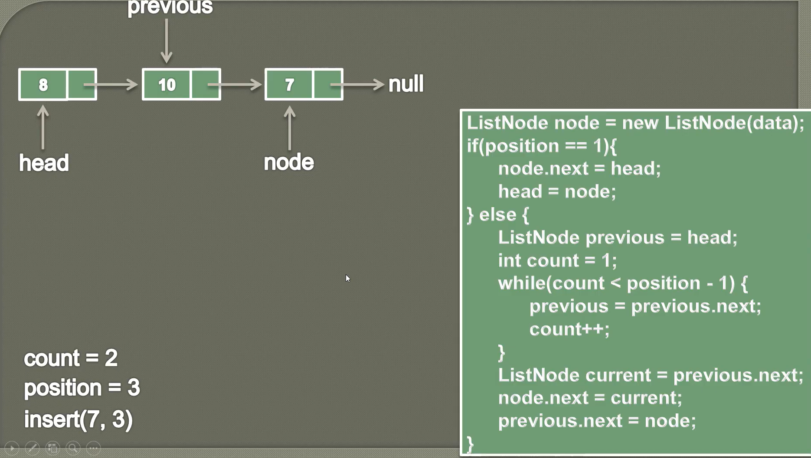

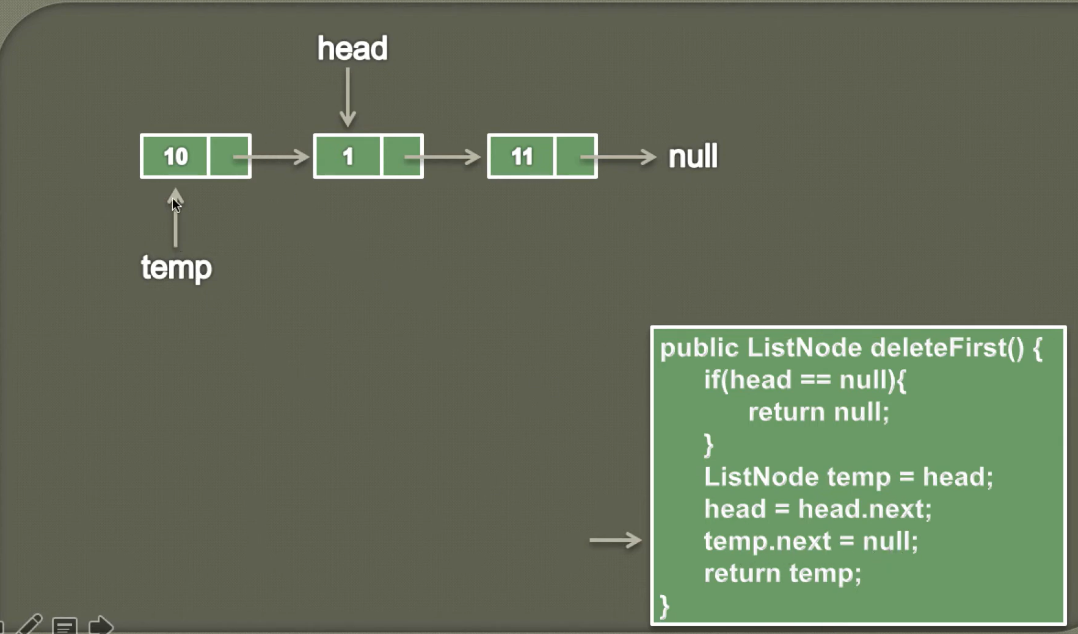

Insert node at the beginning of a Singly Linked List in Java

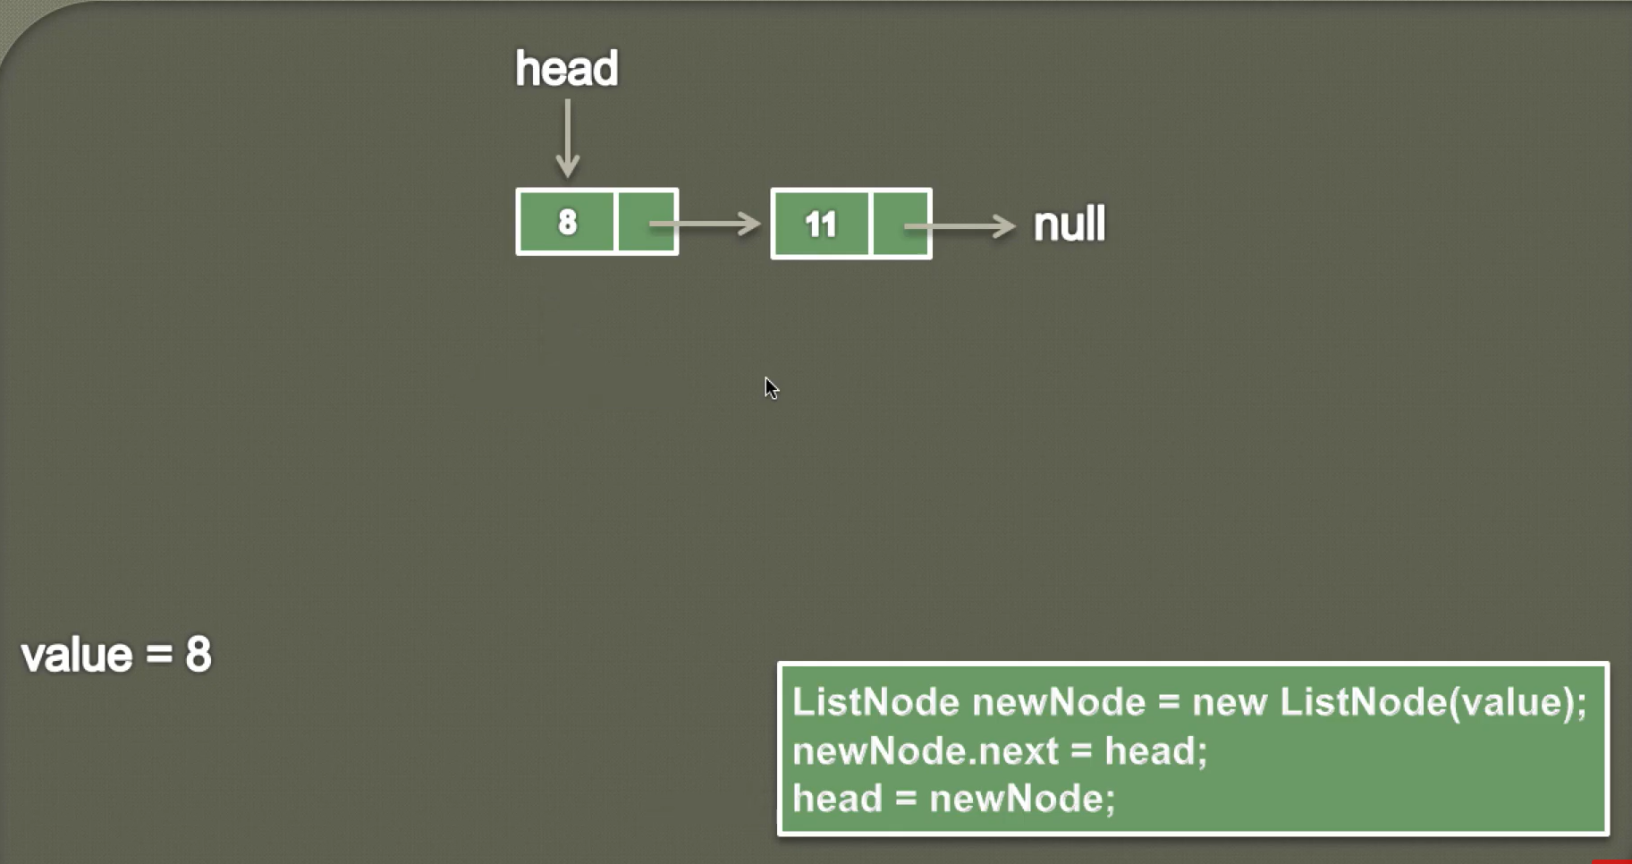

**16th July 2024:**

Video number – 57 - <https://www.youtube.com/watch?v=jY-EUKXYT20&list=PL6Zs6LgrJj3tDXv8a_elC6eT_4R5gfX4d&index=57>

**Reverse a Single Linked List in Java:**

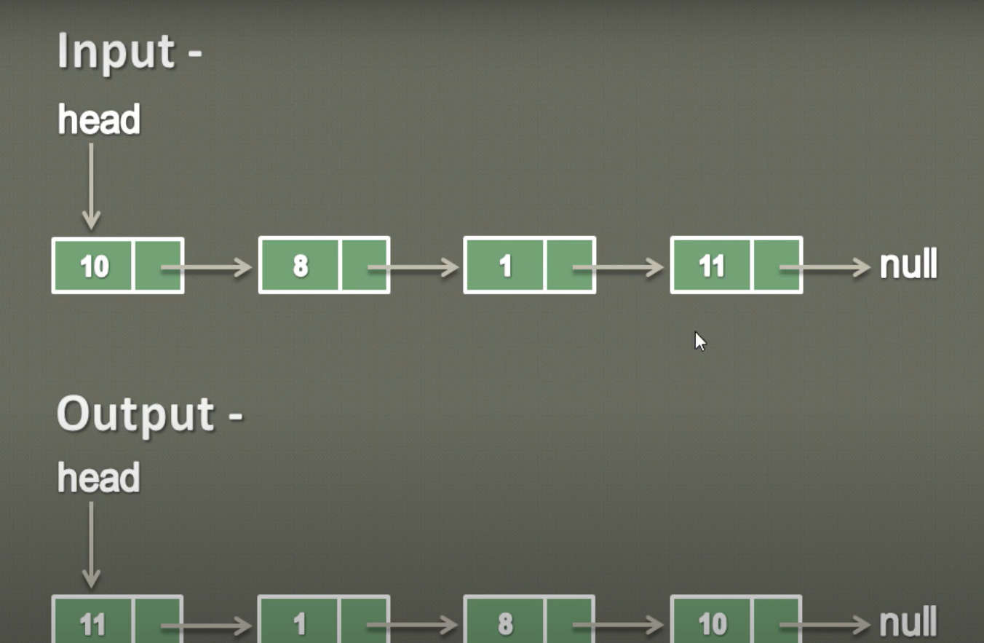

**17th July 2024:**

